Task 5

Embedded Systems

DCSE, UET Peshawar Deadline is: **11-1-2023** **Q1**.

Consider four branch prediction schemes: *predict not taken*, *predict taken*, 1-bit and 2-bit *dynamic prediction*. Assume that they all have *zero* penalty when they predict correctly and *two cycles* when they predict incorrectly. What will be the accuracy of all four types of branch schemes for the following code?

Int k = 0; for (i=5; i>0; i--) { for (j=100; j>0; j--) k++;

}

################## Equivalent assembly code is ################

main:

li $t2, 5 # i = 5

li $t3, 0 # k = 0

outer_Loop:

li $t1,100 # j = 100

inner_Loop:

add $t3, $t3, 1 # k = k + 1

subi $t1, $t1,1 # j = j-1

bne $t1,0, inner_Loop

subi $t2, $t2,1 # i = i-1

bne $t2,0, outer_Loop

################## End of assembly code is ###################

**What will be stored in the $t3 variable at the end of the program.**

At the end of the program $t3 = 500 (1f4 hex).

**Calculate the total penalty incurred due to misprediction in each scheme.**

**1bit predict taken: -**

Misprediction = 9.

Total penalty = 18 cycles.

Accuracy = 491/500 = 98.2%

**1bit predict not taken: -**

Misprediction in the inner loop = 10.

Total penalty = 20 cycles.

Accuracy = 490/500 = 98%

Misprediction in the outer loop = 2.

Accuracy = 3/5 = 60%

**2bit predict taken: -**

Misprediction in the inner loop= 5.

Total penalty = 10 cycles.

Accuracy = 495/500 = 99%

Misprediction in the outer loop = 1.

Accuracy = 4/5 = 80%

**2bit predict not taken: -**

Misprediction in the inner loop= 7.

Total penalty = 14 cycles.

Accuracy = 493/500 = 98.6%

Misprediction in the outer loop = 3.

Accuracy = 2/5 = 40%

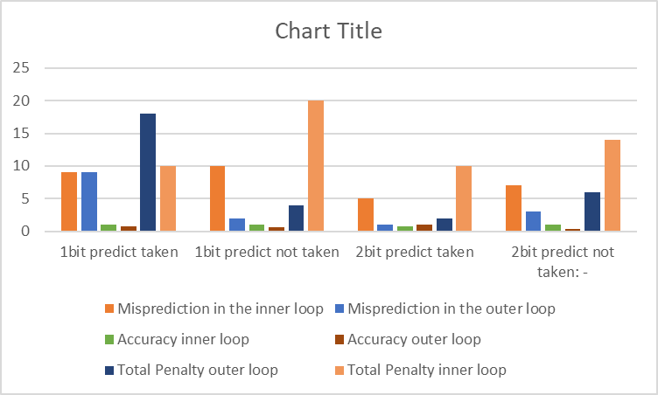

**Compare the penalty among all four schemes using a bar graph.**

**Q2**. Repeat the same task for the following loop.

Int k = 0; for (i=100; i>0; i--) { for (j=5; j>0; j--) k++;

}

**1bit predict taken: -**

Misprediction in the inner loop = 199.

Total penalty = 298 cycles.

Accuracy = 301/500 = 60.2%

Misprediction in the outer loop = 1.

Accuracy = 99/100 = 99%

**1bit predict not taken: -**

Misprediction in the inner loop= 200.

Total penalty = 400 cycles.

Accuracy = 300/500 = 60%

Misprediction in the outer loop = 2.

Accuracy = 98/100 = 98%

**2bit predict not taken: -**

Misprediction in the inner loop= 100.

Total penalty = 200 cycles.

Accuracy = 400/500 = 80%

Misprediction in the outer loop = 1.

Accuracy = 99/100 =99%

**2bit predict not taken: -**

Misprediction in the inner loop= 102.

Total penalty = 104 cycles.

Accuracy = 398/500 = 79.6%

Misprediction in the outer loop = 3.

Accuracy = 97/500 = 97%

Compare the graphs of both Q1 and Q2. Which scheme is better for Q2?

**3.** In this task, an ultra sonic ranger (SRF04) has to be interfaced with an MSP430. This sensor is used to determine the distance of an obstacle from the sensor. Major application for this sensor include obstacle avoidance in toys and small robots. As soon the trigger input pulse (>10usec) is provided by MSP430. The sensor in response sends a sonic burst of eight cycles towards an obstacle. Frequency of these eight cycles of ultrasound is 40kHz. At the end of eighth cycle the sensor raise its echo line high. The sound waves collided with an obstacle and echo back towards the sensor. The echo line is therefore a pulse whose width is proportional to the distance to the obstacle. By determining width of this pulse, it is possible to calculate the distance in inches or centimeters. If nothing is detected, then the SRF04 will lower its echo line anyway after about 36ms. The speed of sound is constant. MSP430 will determine the length of echo pulse and determine the distance. The timing diagram is shown here,

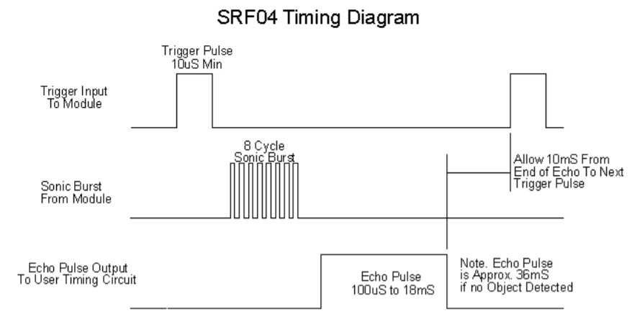

Timing diagram of SRF04 The calculated distance should be displaced on LCD.

**Calculating the Distance:**

The SRF04 provides an echo pulse proportional to distance. If the width of the pulse is measured in usec, then dividing by 58 will give you the distance in cm, or dividing by 148 will give the distance in inches. usec/58=cm or usec/148=inches.

Hint: Use the capture mode of a Timer to determine the width of Echo pulse.

More details: First *2:25 seconds* of this video:

<https://www.youtube.com/watch?v=ZejQOX69K5M>